**DAILY ONLINE ACTIVITIES SUMMARY**

|  |  |  |  |  |  |  |  |  |
| --- | --- | --- | --- | --- | --- | --- | --- | --- |
| **Date:** | **09-06-2020** | | | | | **Name:** | **Deeksha D Poojary** | |
| **Sem & Sec** | **VIII Semester & A Section** | | | | | **USN:** | **4AL16CS026** | |
| **Online Test Summary** | | | | | | | | |
| **Subject** | | **BDA** | | | | | | |
| **Max. Marks** | | **25** | | **Score** | | | **30** | |
| **Certification Course Summary** | | | | | | | | |
| **Course** | **Introduction to Hadoop & Robotic Process Automation** | | | | | | | |
| **Certificate Provider** | | | **Great Learning & Ui Path** | | **Duration** | | | **4 Hours & 3 Hours** |
| **Coding Challenges** | | | | | | | | |
| **Problem Statement: Write a program in C to rotate an array by N positions** | | | | | | | | |
| **Status: COMPLETED** | | | | | | | | |
| **Uploaded the report in Github** | | | | | **YES** | | | |
| **If yes Repository name** | | | | | **deekshapoojari** | | | |
| **Uploaded the report in slack** | | | | | **YES** | | | |

Online Test Details:

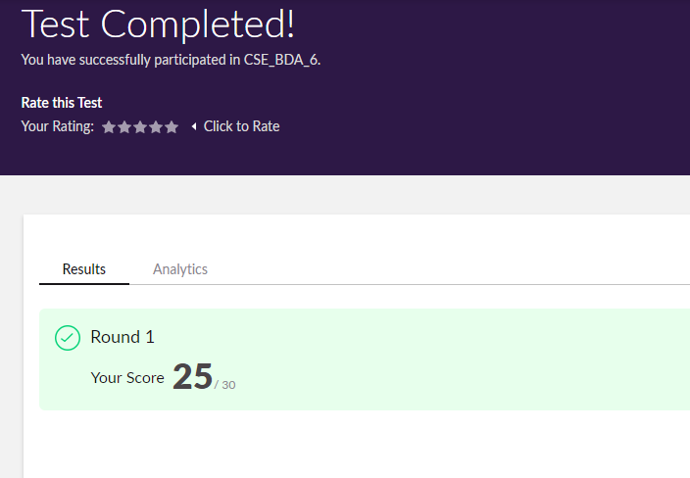

Certification Course Details:



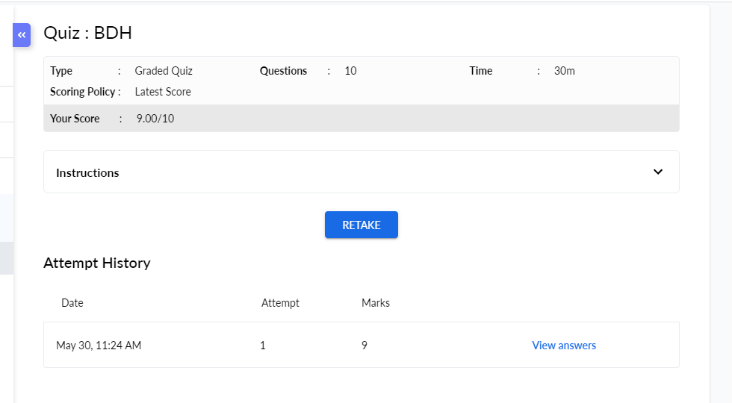

Coding Challenges Details:

|  |
| --- |
|  |
|  |
|  |
|  |
|  |
|  |
|  |
|  |
|  |
|  |
|  |
|  |
|  |
|  |
|  |
|  |
|  |
|  |
|  |
|  |
|  |
|  |
|  |
|  |
|  |
|  |
|  |
|  |
|  |
|  |
|  |
|  |
|  |
|  |
|  |
|  |
|  |
|  |
|  |
|  |
|  |
|  |
|  |
|  |
|  |
|  |
|  |
|  |
|  |
|  |
|  |
|  |
|  |
|  |

**Program1:**

|  |
| --- |
| **#include <stdio.h>** |
|  | **void shiftArrPos(int *arr, int arrSize)** |
|  | **{** |
|  | **int i, temp;** |
|  | **temp = arr[0];** |
|  | **for(i = 0; i < arrSize-1; i++)** |
|  | **{** |
|  | **arr[i] = arr[i+1];** |
|  | **}** |
|  | **arr[i] = temp;** |
|  | **}** |
|  | **void arrRotate(int *arr, int arrSize, int rotFrom)** |
|  | **{** |
|  | **int i;** |
|  | **for(i = 0; i < rotFrom; i++)** |
|  | **{** |
|  | **shiftArrPos(arr, arrSize);** |
|  | **}** |
|  | **return;** |
|  | **}** |
|  | **int main()** |
|  | **{** |
|  | **int arr[10][10];** |
|  | **int i, j, K, n1, n2;** |
|  |  |
|  | **printf("Enter the size of the matrix: ");** |
|  | **scanf("%d%d",&n1,&n2);** |
|  |  |
|  | **printf("Enter the Elements of the matrix:\n");** |
|  | **for(i = 0; i < n1; i++)** |
|  | **for(j = 0; j < n2; j++)** |
|  | **scanf("%d",&arr[i][j]);** |
|  |  |
|  | **printf("Enter the value of K: ");** |
|  | **scanf("%d", &K);** |
|  |  |
|  | **printf("Matrix before rotation\n");** |
|  | **for(i = 0; i < n1; i++)** |
|  | **{** |
|  | **for(j = 0; j < n2; j++)** |
|  | **printf("%d ",arr[i][j]);** |
|  | **printf("\n");** |
|  | **}** |
|  |  |
|  | **for(i = 0; i < n1; i++)** |
|  | **arrRotate(arr[i], n2, K);** |
|  |  |
|  | **printf("Matrix after rotation\n");** |
|  | **for(i = 0; i < n1; i++)** |
|  | **{** |
|  | **for(j = 0; j < n2; j++)** |
|  | **printf("%d ",arr[i][j]);** |
|  | **printf("\n");** |
|  | **}** |
|  |  |
|  | **return 0;** |
|  | **}** |